**Excel Assignment – 16**

Que.1) What is a Macro? How is it useful in excel or in your daily work?

Ans. – A macro is an action or a set of actions that you can run as many times as you want. When you create a macro, you are recording your mouse clicks and keystrokes.

It helps to do tasks which require repeated actions in Microsoft Excel by automating those tasks.

Que.2) What is VBA? Write its full form and briefly explain why VBA is used in excel?

Ans. – VBA stands for Visual Basic Analysis. Visual Basic for Application is a human-readable and editable programming code that gets generated when you record a macro. Today, it is widely-used with other Microsoft Office applications such as MS-Word, MS Excel, and MS-Access.

It is used in excel to create macros.

Que.3) How do you record a macro? Write detailed steps to create a macro to automatically make the following table in bold and to create borders for it in excel.

hi 78

hello 69

ineuron 45

Ans. – To create a macro we follow the steps given below:

* 1. On the View tab, in the Macros group, click the Macros command.
  2. Click Record Macro.
  3. In the Record Macro dialog box:
     1. Enter a Macro name. Choose a name that clearly identifies the macro. You may not use spaces.
     2. Enter a Shortcut key. You will be able to run the macro using this shortcut key.
     3. Choose where to store the macro. You will normally accept the default (This Workbook).
     4. Enter a Description. Briefly explain what the macro does.
     5. Click OK.
  4. After clicking OK, every keystroke is recorded.
  5. To stop recording, on the View tab, in the Macros group, click the Macros command and then click Stop Recording.

To make the given table bold, we first start recording Macro by following above described steps. Then manually bold and create borders for that table. After that stop recording Macro. The macro will be saved.

We can run that macro later on to do these formatting in future automatically.

Que.4) What do you mean when we say VBA Editor?

Ans. – Excel's VBA editor is a powerful tool. It lets you write and edit custom scripts that automate actions in Excel. In fact, when you record a macro it is stored in VBA code in the VBA editor.

But writing a macro from the VBA editor directly gives you more flexibility than recording a macro in the traditional manner.

You can create better code and complete more complicated tasks by working directly with Visual Basic for Applications.

Que.5) Briefly describe the interface of a VBA editor? What is properties window? And what is watch window? How do you display these windows?

Ans. – The basic VBE window can be divided in the following 6 sections as shown in following screenshot:

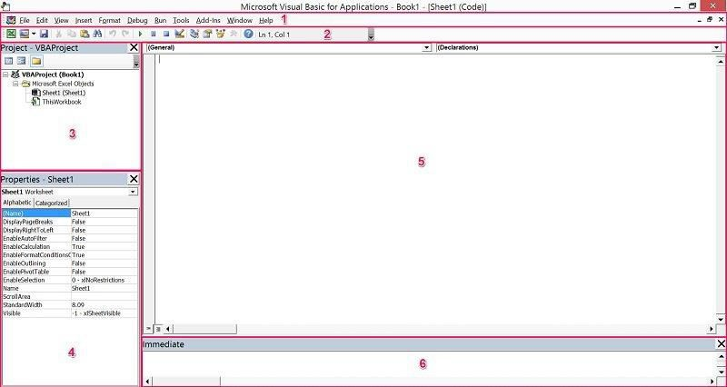

The Properties Window displays the properties of the object that is currently selected in the Project Explorer and allows you to edit those properties.

Properties Window can be displayed by using any of the following methods:

1. Clicking on “Properties Window” within the View menu.
2. How to display the Properties Window in the VBE
3. Clicking on the Properties Window icon.
4. Properties Window icon in VBE
5. Using the “F4” keyboard shortcut.

A watch is a variable or expression that has been placed in the window to enable you to monitor its value. Let’s you watch the values of variables and expressions as your code executes.

When your application enters break mode, the watch expressions you select appear in a window allowing you to observe their values etc. It is also possible to set up conditional watches.

This window is automatically updated after each line of code is executed.

Que.6) What is an immediate Window and what is it used for?

Ans. – The Immediate window displays information resulting from debugging statements in your code or from commands typed directly into the window.

To display the Immediate window choose immediate window (CTRL+G) from view menu.

To execute code in the Immediate window type a line of code in the immediate window. Press ENTER to execute the statement.

We can use the immediate window to:

* Test problematic or newly written code.
* Query or change the value of a variable while running an application. While execution is halted, assign the variable a new value as you would in code.
* Query or change a property value while running an application.
* Call procedures as you would in code.
* View debugging output while the program is running.